**Tutorial 17**

**Name**:Bhavin Patil

**Roll No:** 66

**TY-CS-D**

Statement: Creating Smart Contract using Solidity and Remix IDE.

// SPDX-License-Identifier: MIT

pragma solidity ^0.8.13;

contract Counter {

    uint public count;

    // Function to get the current count

    function get() public view returns (uint) {

        return count;

    }

    // Function to increment count by 1

    function inc() public {

        count += 1;

    }

    // Function to decrement count by 1

    function dec() public {

        // This function will fail if count = 0

        count -= 1;

    }

}

**Compiler**

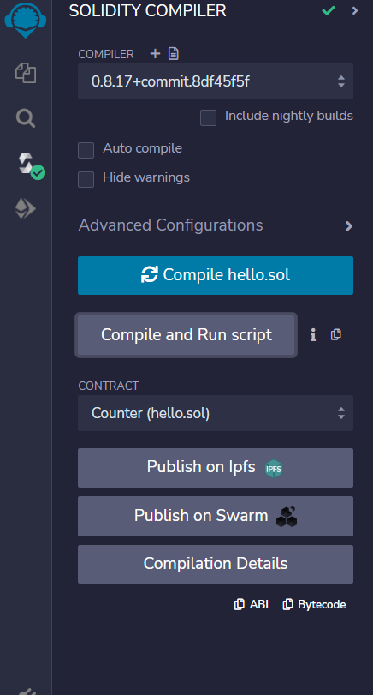

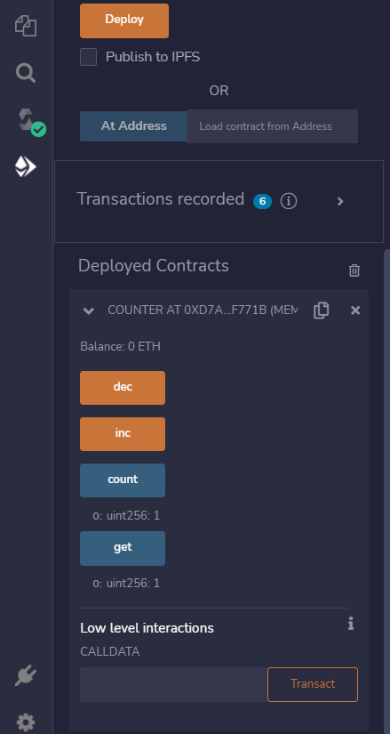 **Deploy:**

